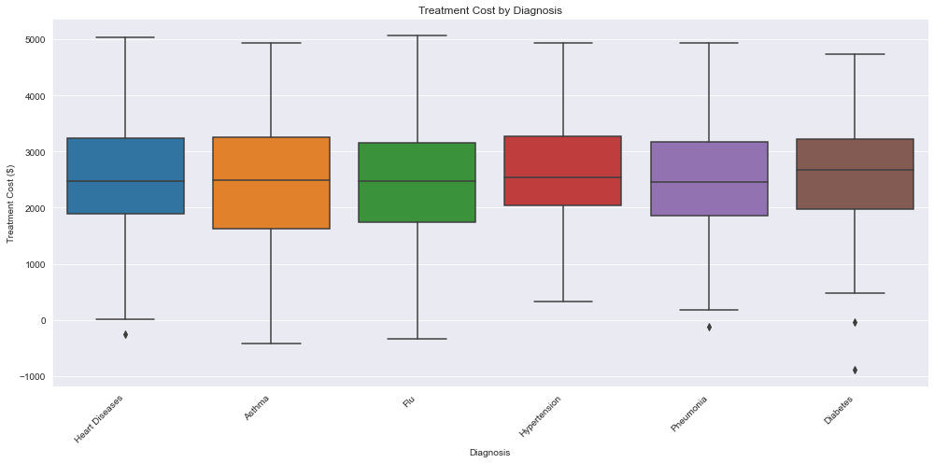A graph showing age vs.

